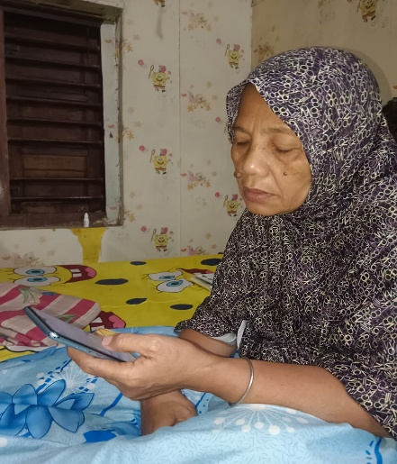
MOTHER

Good morning Sir, allow me to introduce myself, my name is Muhammad Raditya Alfajri. I would like to introduce my mother, her name is Saisah. My mother is old, she is 60 years o ld. My mother's daily life is taking care of household chores such as cooking, washing clothes, and cleaning the house. She always prepares her children's needs when they goes to work or college. My mother is also known as a very cheerful person, she is always friendly to her neighbors and that makes her known to everyone. With my mother's friendly nature, it also makes people around her like my mother.
My mother works very hard in caring for her children. she does not want her children to get sick. When one of her children fell ill, my mother immediately took care of her. She was worried about what was wrong with her child, so she paid more attention to her child. She also had a firm and disciplined attitude towards people at home. My mother did seem firm and a little emotional when managing her children, but she did it because she loved her children. Her firm nature was also to make her children disciplined. Behind her firm attitude when her children were having problems, she always listened to her children's stories and gave more attention so that her children would be enthusiastic again.
In her free time, when there is no more household work, my mother likes watching YouTube or usually opens Facebook until she falls asleep while playing on her phone. She really likes video reels on Facebook, especially if the video is about a Chinese drama that is currently viral. I really love my mother, she is the best figure in my life. If he wasn't there, my life would probably be a mess, i am so grateful for my mother. I promise to make him happy as he makes me happy.

